**SPACE TRAVELLER**

**A PROJECT REPORT**

**Submitted by**

**SHREY SHARMA [Reg No:RA2211051010010]**

**ABHIJEET SHARMA [Reg No:RA2211051010032]**

**ASHISH ARYA[Reg No:RA2211051010041]**

**Under the guidance of**

**Dr. P.ESWARAN, Ph.D.**

**(Associate Professor, Department of Electronics and Communication & Engineering)**

**in partial fulfillment for the award of the degree**

**of**

**BACHELOR OF TECHNOLOGY**

**in**

**ELECTRONICS AND COMMUNICATION**

**ENGINEERING**

**Of**

**FACULTY OF ENGINEERING AND TECHNOLOGY**



**S.R.M. Nagar, Kattankulathur, Kancheepuram District**

**MAY 2019**

**ABSTRACT**

The Space Traveller Game, a captivating 2D endless runner

experience created on Unity, immerses players in the thrilling

role of piloting aircraft through dynamic environments. This

abstract encapsulates the game's development process,

methodology, and key findings. From hardware and software

design considerations to implementation details and

performance metrics, it provides insights into the game's

creation. Innovative gameplay mechanics, including dynamic

level generation and score tracking systems, deliver an

engaging user experience. Future enhancements aim to

expand features and enhance player immersion. Embark on

an exhilarating journey through the skies with the Flight

Runner Game on Unity.

**ACKNOWLEDGEMENT**

We express our heartfelt thanks to our honorable Vice Chancellor

Dr. C. MUTHAMIZHCHELVAN, for being the beacon in all our endeavors.

We would like to express my warmth of gratitude to our Registrar

Dr. S. Ponnusamy, for his encouragement.

We express our profound gratitude to our Dean (College of

Engineering and Technology) Dr. T. V. Gopal, for bringing out novelty in all executions.

We would like to express my heartfelt thanks to Chairperson, School of Computing Dr. Revathi Venkataraman, for imparting confidence to complete my course project

We wish to express my sincere thanks to Course Audit Professors Dr. Vadivu. G , Professor, Department of Data Science and Business Systems and Dr. Sasikala. E Professor, Department of Data Science and Business Systems and Course Coordinators for their constant encouragement and support.

We are highly thankful to our my Course project Faculty Rajalakshmi D , Professor at SRM ,DSBS, for her assistance, timely suggestion and guidance throughout the duration of this course project.

We extend my gratitude to our HoD & GT ; & lT ; Designation & GT;, & lT ;Department & GT; and my Departmental colleagues for their Support.

Finally, we thank our parents and friends near and dear ones who directly and indirectly contributed to the successful completion of our project . Above all, I thank the almighty for showering his blessings on me to complete my Course project.

INDEX

S.NO TITLE PAGE NO

1 INTRODUCTION 1-3

1.1 Brief discussion of the game

1.2 Literature Survey

2 METHADOLOGY 4-5

3 IMPLEMENTATION 6-7

3.1 Experimental Setups

3.2 Program logic for parameters

4 RESULTS AND DISCUSSION 8-9

5 CONCLUSION AND FUTURE 9-10

PLANS

**INTRODUCTION**

Welcome to the Space Traveller Game, an electrifying 2D endless runner experience designed to ignite your passion for high-flying adventure! In this adrenaline-fueled journey, players take on the exhilarating role of piloting aircraft through dynamically generated landscapes, each more breathtaking and challenging than the last. As you navigate the skies, you'll soar above majestic mountains, weave through towering skyscrapers, and dive into narrow canyons, all while dodging obstacles and collecting power-ups to enhance your flight. With intuitive controls and stunning visuals, the Space Traveler Game offers an immersive escape into the world of aerial acrobatics. Whether you're a seasoned pilot or a novice adventurer, the game's dynamic gameplay and addictive challenges will keep you coming back for more. So buckle up, prepare for takeoff, and get ready to embark on the flight of a lifetime. The skies await your command in the Space Traveler Game - where every moment is a pulse-pounding thrill ride!

1.1 Brief description of the project

The Space Traveler Game is a captivating 2D endless runner experience developed on Unity. Players take control of an aircraft and navigate through dynamically generated environments filled with obstacles and power-ups. The game offers intuitive controls, stunning visuals, and addictive gameplay mechanics, providing an immersive journey through the skies. From dodging obstacles to collecting power-ups, players must showcase their piloting skills to achieve the highest score possible. With future enhancements planned to expand features and enhance player immersion, the Space Traveler Game promises an exhilarating adventure that will keep players engaged for hours on end

1.2 Literature Survey

Runner games, also known as endless runner games, have become a popular genre in the world of gaming, captivating players with their simple yet addictive gameplay mechanics. Numerous studies and research articles have explored various aspects of runner games, including their design principles, player engagement strategies, and technological advancements. Here are some key findings from the literature survey:

Gameplay Design Principles:

Research has highlighted the importance of intuitive controls, dynamic level generation, and balanced difficulty progression in runner games. Studies suggest that well-designed levels with a mix of obstacles and power-ups contribute to player engagement and retention.

Player Engagement Strategies:

Studies have examined different player engagement techniques employed in runner games, such as reward systems, achievement mechanisms, and social integration features. These strategies aim to enhance player motivation and prolong gameplay sessions.

Technological Advancements:

Research has explored the role of technological advancements, such as procedural generation algorithms and real-time physics simulations, in shaping the gameplay experience of runner games. These advancements enable developers to create dynamic and immersive environments that adapt to player actions.

User Experience Design:

Literature has emphasized the importance of user experience design in runner games, focusing on aspects such as interface layout, visual aesthetics, and sound design. Studies suggest that a well-crafted user experience enhances player immersion and enjoyment.

Impact of Runner Games on Health and Well-being:

Some research has investigated the potential health benefits of playing runner games, such as improving cognitive function, reducing stress levels, and promoting physical activity through gamified exercise routines.

Overall, the literature survey underscores the significance of runner games as a popular and engaging genre that continues to evolve with advancements in technology and design methodologies. By understanding the underlying principles and player preferences, developers can create compelling runner games that captivate audiences and provide memorable gaming experiences.

**METHADOLOGY**

The development of the Space Traveler Game involved a structured approach that encompassed several key stages, each contributing to the overall design, implementation, and testing of the game. Here's an overview of the methodology employed in creating the Space Traveler Game:

Conceptualization:

The initial phase involved conceptualizing the game idea and defining its core features, gameplay mechanics, and target audience. Brainstorming sessions and market research helped identify popular trends in the endless runner genre and determine unique selling points for the game.

Design Planning:

Once the concept was finalized, the next step was to plan the game's design architecture, including its graphical assets, level layout, user interface elements, and sound effects. Design documents and mockups were created to visualize the game's aesthetics and user experience.

Development Tools Selection:

The choice of development tools played a crucial role in the implementation of the game. Unity, a popular game engine, was selected for its versatility, ease of use, and robust feature set. Additional software tools, such as graphic design software and audio editing tools, were also employed for asset creation.

Prototyping:

Prototyping involved creating a basic version of the game to test its core mechanics and gameplay loop. This iterative process allowed for rapid iteration and refinement of gameplay features, ensuring a polished experience before full-scale development.

Art Asset Creation:

The creation of art assets involved designing and producing visuals for the game, including character sprites, background elements, obstacles, and special effects. A cohesive art style was maintained to ensure visual consistency and enhance the game's aesthetic appeal.

Programming Implementation:

The programming phase focused on implementing the game's functionality, including player controls, obstacle generation, scoring mechanics, and user interface interactions. Object-oriented programming principles were employed to maintain code modularity and flexibility.

Testing and Debugging:

Throughout the development process, extensive testing and debugging were conducted to identify and resolve any bugs, glitches, or gameplay imbalances. Both manual testing and automated testing tools were utilized to ensure the game's stability and performance across different devices.

Feedback and Iteration:

Feedback from play testers and beta users played a crucial role in refining the game's design and addressing any usability issues or gameplay concerns. Iterative updates were released based on user feedback, with continuous improvement efforts aimed at enhancing the overall player experience.

Finalization and Release:

Once the game was polished and thoroughly tested, it was prepared for release on digital distribution platforms such as app stores and online gaming portals. Marketing strategies were employed to promote the game and attract a wider audience.

**IMPLEMENTATION**

Experimental Setups

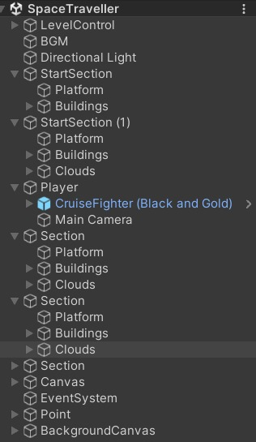 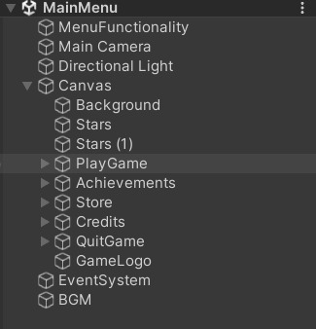

Program logic for parameters

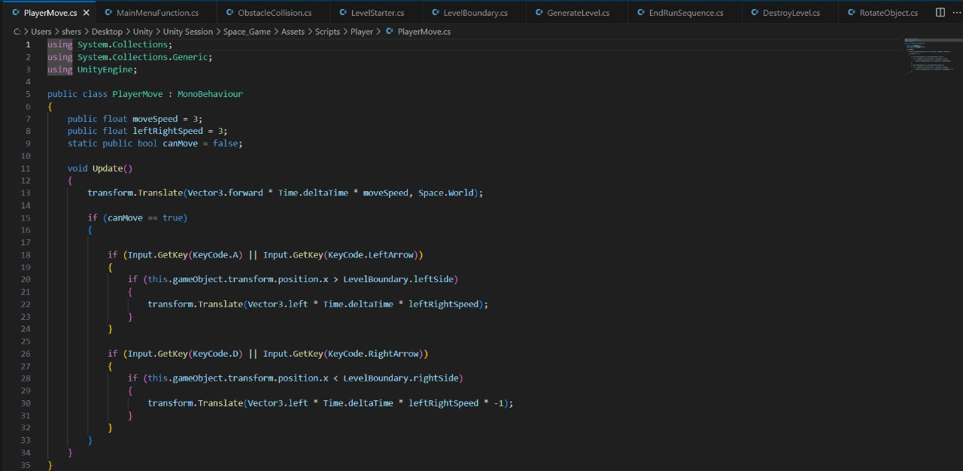

**RESULTS AND DISCUSSION**

**MAIN MENU**

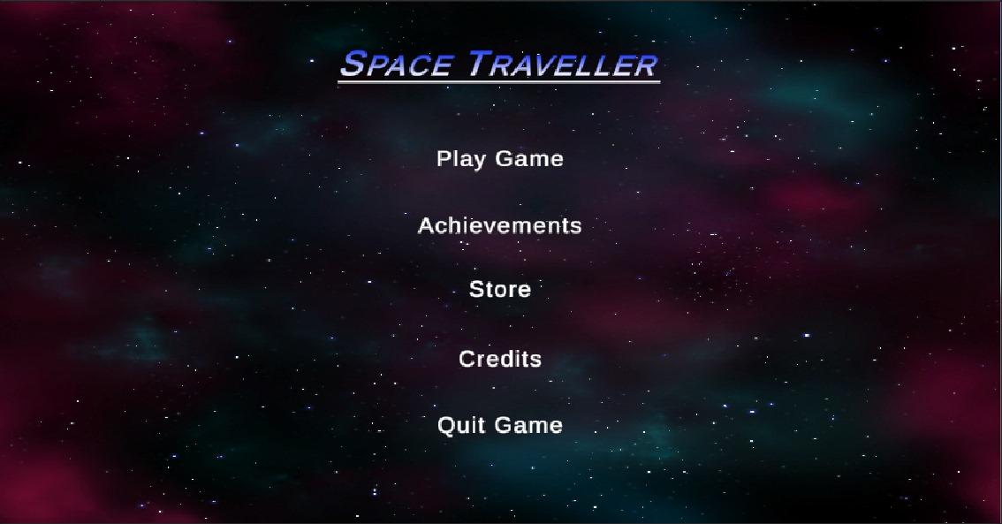

**ASSET**

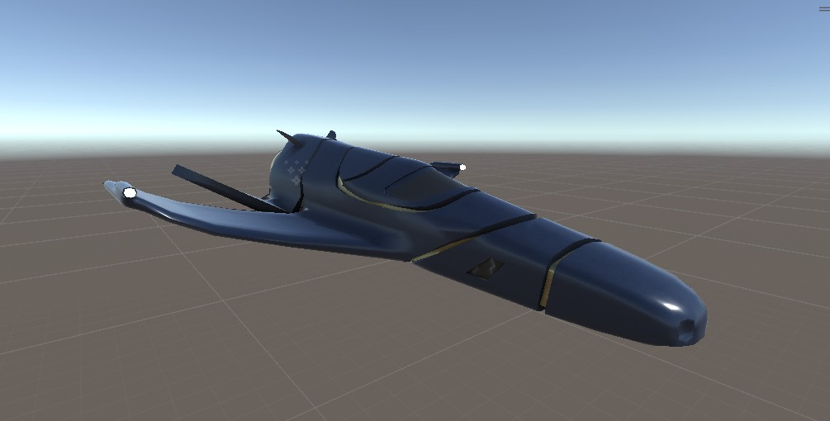

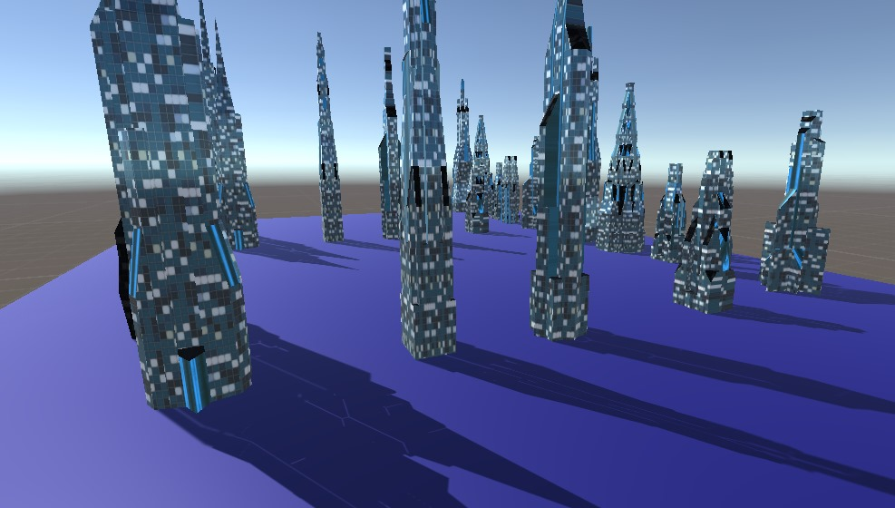

**LEVEL**

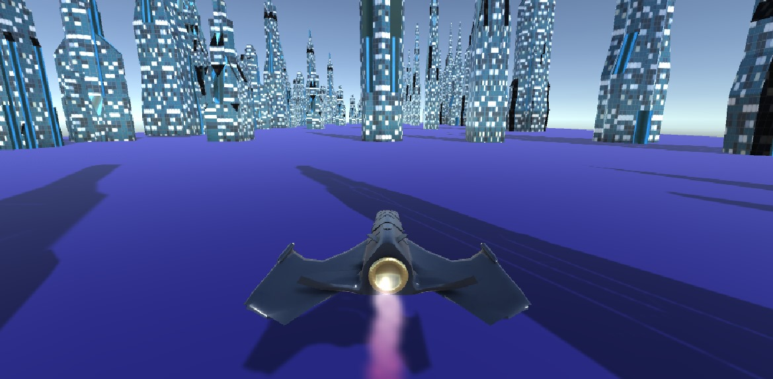

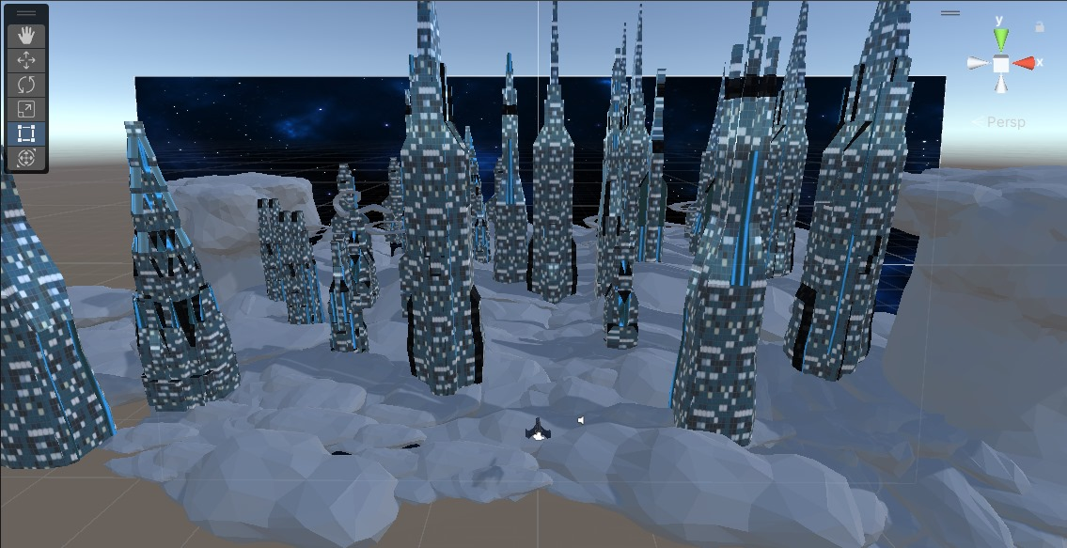

**PLAYER VIEW**

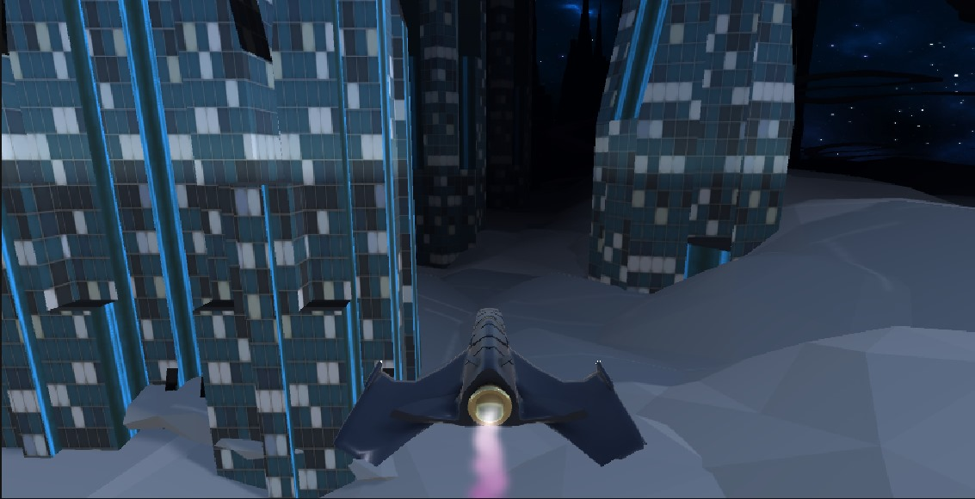

**GAME START**

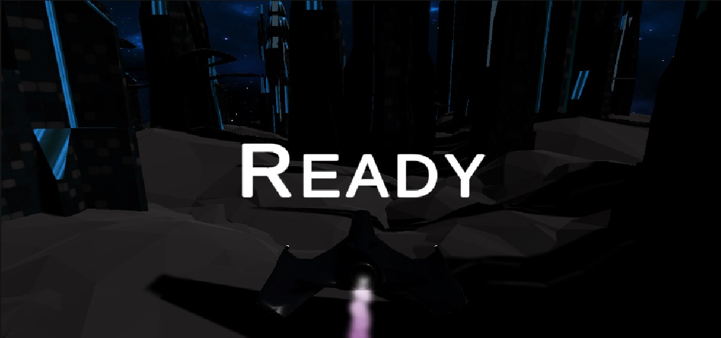

**GAME OVER**

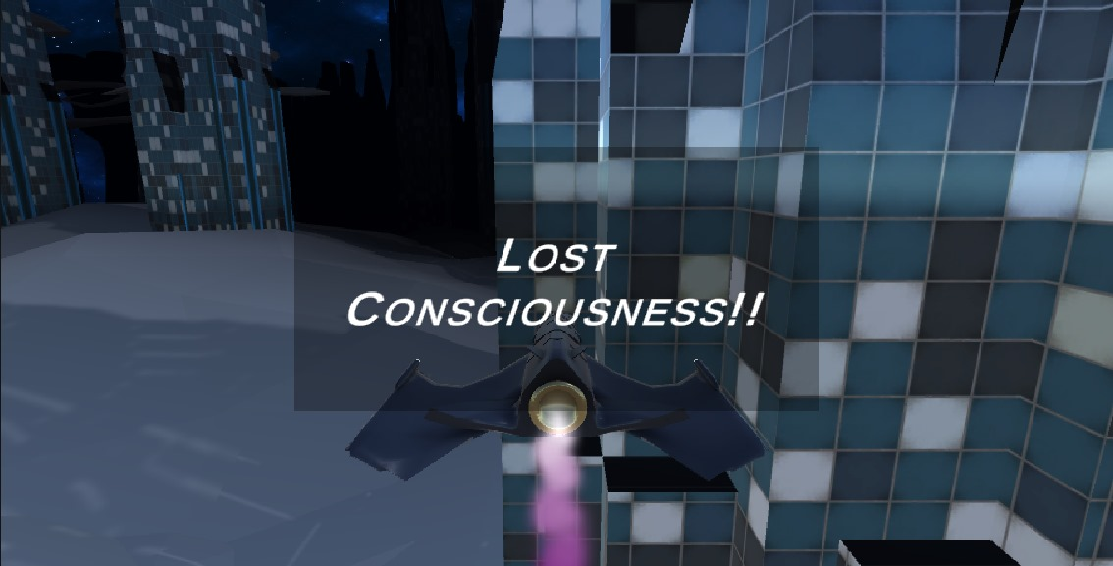

**CONCLUSION AND FUTURE ENHANCEMENTS**

1.New Levels and Environments: Introducing new levels with unique themes and environments, ranging from lush forests and icy tundra’s to futuristic cityscapes and alien worlds.

2.Additional Aircraft and Characters: Adding a variety of aircraft and characters for players to unlock and customize, each with its own unique abilities and traits.

3.Power-Ups and Upgrades: Introducing new power-ups, upgrades, and special abilities to enhance gameplay and provide players with strategic options for overcoming challenges.

4.Multiplayer Mode: Implementing a multiplayer mode that allows players to compete against friends or other players online in thrilling aerial races and challenges.

5.Community Engagement: Engaging with the player community to gather feedback, suggestions, and ideas for further improving the game and ensuring that it remains a beloved favorite among players.

By continuing to innovate, iterate, and listen to player feedback, the Space Traveler Game will evolve into an even more immersive, exciting, and memorable gaming experience that brings joy and excitement to players around the world. The sky's the limit for the future of the Space Traveler Game!

**Roles :-**

*Abhijeet Sharma :* Sound Design, Asset Creation

*Shrey Sharma :*  Level Design, Scripting

*Ashish Arya :*  Game Design, Scripting